Faculty of Engineering and Technology
Electrical and Computer Engineering Department

Machines Lab (ENEE3101)

Student’s name: abed-Alrahman Hmedan
Student’s number: 1161306
Report for Experiment #11
Single phase IM and split phase IM
Date 20/5/2019
Eng. Mostafa Helal
Dr. Ali Abdo
Partners name partners ID:
Ahmed Nabeel 1160449
Ahmed Alkhateb 1161535

Abstract:

The Aim of experiment:
Connecting a capacitor run motor, a capacitor start motor, a capacitor start and capacitor run motor, a split phase induction motor and reversing the direction of rotation. Also, performing measurements to determine the motor’s efficiency and making a comparison of this value to the value derived from the rating plate. In addition to recording and interpreting various load characteristics of the capacitor motor and investigating the influence of its starting capacitor. Moreover, measuring and interpreting the motor’s load and run-up characteristics with computer aided techniques. And finally, recording and interpreting various load characteristics of split phase induction motor.

Equipment list :

1 capacitor motor F 732 06
1 bifilar-wound motor 732 05
1 machine test system 731989
1 CBM 10 computer-based analysis of electrical machines, V.5.76 728421
1 power circuit breaker module 745 561
1 RMS meters 727 10
1 power factor meter 727 12
1 motor protection switch 1 ... 1.6 A 732 14
1 isolating variable transformer, 0 …260 V 726 85

Table of Contents
Abstract: 2
The Aim of experiment: 2
Equipment list : 2
Theory : 4
Procedure, data and calculation 8
A. Capacitor Run Motor 8
B. Capacitor start motor 12
C. Computer based Recording of Run-up Characteristics of capacitor motor 14
D. Separate winding induction motor (bifilar wound motor) 15
Conclusion: 19
References: 19

Table of Figure
Figure 1: connection for studying the capacitor run motor 8
Figure 2:load characteristic of capacitor run motor 12
Figure 3: the circuit to study the capacitor start motor 12
Figure 4:load characteristic for start motor 13
Figure 5:Circuit connection for capacitor start capacitor run motor 14
Figure 6: Torque-speed characteristic for IM 15
Figure 7: Circuit for studying separate winding induction motor 15
Figure 8:load characteristic for split phase IM 18
Figure 9:Computerized curve that represent the torque speed characteristic for split-phase IM 18

Theory :
Single phase motors are very widely used in home, offices, workshops.., since the power delivered to most of the houses and offices is single phase. In addition to this, single phase motors are reliable, cheap in cost, simple in construction and easy to repair.

Single phase electric motors can be classified as:
-Single phase induction motor (Split phase, Capacitor type and shaded pole) - Single phase synchronous motor -Repulsion motor.
In this experiment, single phase induction motor is investigated and studied. The construction of a single phase induction motor is similar to the construction of three phase induction motor having squirrel cage rotor, except that the stator is wound for single phase supply; having only one winding (main winding) fed from a single phase AC source.
The Working Principle of Single Phase Induction Motor is explained as follows; when the stator of a single phase motor is fed with single phase supply, it produces alternating flux in the stator winding. The alternating current flowing through stator winding causes induced current in the rotor bars (of the squirrel cage rotor ) according to Faraday's law of electromagnetic induction. This induced current in the rotor will also produce alternating flux. Even after both alternating fluxes are set up, the motor fails to start. However, if the rotor is given an initial start by external force in either direction, then motor accelerates to its final speed and keeps running with its rated speed. This behavior of a single phase motor can be explained by double-field revolving theory.
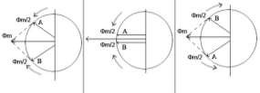
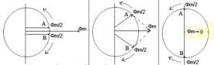
The double-field revolving theory states that, any alternating quantity (here, alternating flux) can be resolved into two components having magnitude half of the maximum magnitude of the alternating quantity, and both these components rotating in opposite direction.
.A single phase induction motor is not self-starting; the stator of a single phase induction motor is wound with single phase winding. When the stator is fed with a single phase supply, it produces alternating flux (which alternates along one space axis only). Alternating flux acting on a squirrel cage rotor can not produce rotation, only revolving flux can.
In order to solve the starting problem and turn this motor into self-starting motor, it can be temporarily converted into a two-phase motor while starting. This can be achieved by introducing an additional 'starting winding' also called as auxiliary winding. Hence, stator of a single phase motor has two windings; main winding and starting winding (auxiliary winding). These two windings are connected in parallel across a single phase supply and are spaced 90 electrical degrees apart. Phase difference of 90 degree can be achieved by connecting a capacitor in series with the starting winding.
Hence the motor behaves like a two-phase motor and the stator produces revolving magnetic field which causes rotor to run. Once the motor gathers speed, the starting winding gets disconnected form the circuit by means of a centrifugal switch, and the motor runs only on main winding.
The single phase induction motors are classified as:
-Split phase induction motor.
-Capacitor start inductor motor.
-Capacitor start capacitor run induction motor.
-Permanent split capacitor (PSC) motor.
-Shaded pole induction motor.

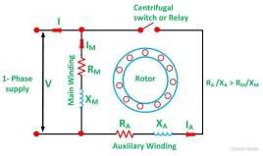
The Split Phase has a single cage rotor, and its stator has two windings known as main winding and starting winding. Both windings are displaced 90 degrees in space. The main winding has very low resistance and a high inductive reactance whereas the starting winding has high resistance and low inductive reactance. The Connection Diagram of the motor is shown next. A resistor is connected in series with the auxiliary winding. The current in the two windings is not equal as a result the rotating field is not uniform. Hence, the starting torque is small. As soon as the motor reaches the speed of about 70 to 80 % of the synchronous speed the starting winding is disconnected from the supply mains, making the motor runs on the main winding only.
The Torque Speed Characteristic of the Split Phase motor is shown beside. And the phasor diagram of the Split Phase Induction Motor is shown below:

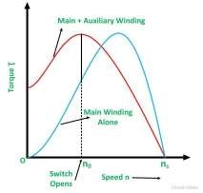
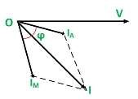
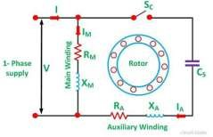
The current in the main winding (I_{M}) lag behind the supply voltage V almost by the 90-degree angle. The current in the auxiliary winding I_{A} is approximately in phase with the line voltage. Thus, there exists the time difference between the currents of the two windings. The time phase difference ϕ is not 90 degrees, but of the order of 30 degrees. This phase difference is enough to produce a rotating magnetic field.
A Capacitor Start Motors are a single phase IM that employs a capacitor in the auxiliary winding circuit to produce a greater phase difference between the current in the main and the auxiliary windings. The name capacitor starts itself shows that the motor uses a capacitor for the purpose of the starting. The figure beside shows the connection diagram of a Capacitor Start Motor.
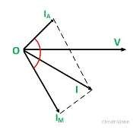
The Phasor Diagram of the Capacitor Start motor is shown below.

I_{M} is the current in the main winding which is lagging the auxiliary current I_{A} by 90 degrees as shown in the phasor diagram. Thus, a single phase supply current is split into two phases. The two windings are displaced apart by 90 degrees electrical, and their MMF’s are equal in magnitude but 90 degrees apart in time phase.
The motor acts as a balanced two-phase motor. As the motor approaches its rated speed, the auxiliary winding and the starting capacitor is disconnected automatically by the centrifugal switch provided on the shaft of the motor.
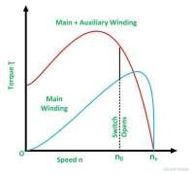
The capacitor starts motor develops a much higher starting torque of about 3 to 4.5 times of the full load torque. To obtain a high starting torque, the two conditions are essential. They are as follows: ▪ The Starting capacitor value must be large.
▪ The valve of the starting winding resistance must be low. The Torque Speed Characteristic of the motor is shown beside. The characteristic shows that the starting torque is high. The cost of this motor is more as compared to the split phase motor because of the additional cost of the capacitor
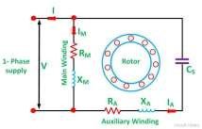
The Permanent Split Capacitor motor has only one capacitor connected in series with the starting winding. The capacitor C is permanently connected in the circuit both at the starting and the running conditions.
The connection diagram of a Permanent Split Capacitor Motor is shown beside.
The auxiliary winding is always there in the circuit. Therefore, the motor operates as the balanced two-phase motor. The motor produces a uniform torque and has noise free operation.
This motor has the following advantages:
-No centrifugal switch is required.
-Efficiency is high.
-As the capacitor is connected permanently in the circuit, the power factor is high. -It has a higher pullout torque.
The limitations of the motor are as follows:-
-The paper capacitor is used in the motor as an Electrolytic capacitor cannot be used for continuous running. The cost of the paper capacitor is higher, and size is also large as compared to the electrolytic capacitor of the same ratings. -It has low starting torque, less than full load torque.

The Capacitor Start Capacitor Run Motor has two capacitors; one is used at the time of the starting and is known as starting capacitor. The other one is used for continuous running of the motor and is known as run capacitor. Connection diagram of this motor is shown beside.
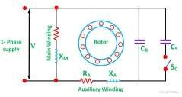
As the motor reaches the synchronous speed, the starting capacitor Cs is disconnected from the circuit by a centrifugal switch Sc. The capacitor C_{R} is connected permanently in the circuit and thus it is known as RUN Capacitor. The run capacitor is long time rated and is made of oil filled paper. The figure below shows the Phasor Diagram of the Capacitor Start Capacitor Run Motor.
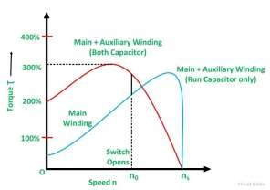
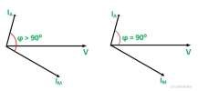
The first figure shows the phasor diagram when at the starting both the capacitor are in the circuit and ϕ > 90⁰. The second figure shows the phasor when the starting capacitor is disconnected, and ϕ becomes equal to 90⁰.The Torque Speed Characteristic of a Capacitor Start Capacitor Run Motor is shown beside.
This type of motor is quiet and smooth running. They have higher efficiency than the motors that run on the main windings only. They are used for loads of higher inertia requiring frequent starts where the maximum pull-out torque and efficiency required are higher. The Two Value Capacitor Motors are used in pumping equipment, refrigeration, air compressors, etc.

Procedure, data and calculation

A. Capacitor Run Motor
The equipment were set as shown in Figure 11-1, and the isolating variable transformer 726 85 was set to give 230 V, then all required modules were turned on. After that, the ON button of the power circuit breaker module 745 561 was pressed to supply the motor with power, and the following measurements were taken:
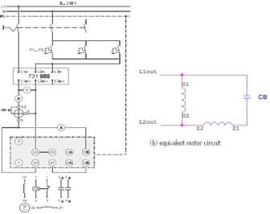
-The supply voltage: 230 V
Figure 1: connection for studying the capacitor run motor
-The motor speed: 1489 rpm
-Direction of rotation looking to the motor from left to right: Clockwise

Finally, the OFF button of the power circuit breaker module 745 561 was pressed.
Q1: How do you reverse the direction of rotation?
Ans: We reverse the direction of rotation by swapping the connections of the auxiliary windings (Z1 and Z2) or the main windings (U1 and U2).
The necessary connection adjustments were made to reverse the direction of rotation, then the ON button of the power circuit breaker module 745 561 was pressed and the following measurements were taken:
-The supply voltage: 230 V
-The motor speed: 1489 rpm
-Direction of rotation looking to the motor from left to right: Counter Clockwise.
After that, the OFF button of the power circuit breaker module 745 561 was pressed and the running capacitor and the auxiliary winding was disconnected.
Then, the DUT enable connection was disconnected from the Power circuit breaker module and its Relay input was connected to its logic zero pin. Next, the shaft cover was removed, and the isolating variable transformer 726 85 was set to give 160 V, then the ON button of the Power circuit breaker module was pressed, and the motor shaft was turned clockwise by hand.
Observed result: the motor shaft continued to turn in the same direction.
Next, the OFF button of the power circuit breaker module 745 561 was pressed
Q2: Why the motor could not start until you provided it with an initial torque? Explain? Ans: As explained in the theory, a single phase induction motor is not self-starting; the stator of a single phase induction motor is wound with single phase winding. When the stator is fed with a single phase supply, it produces alternating flux (which alternates along one space axis only). Alternating flux acting on a squirrel cage rotor can not produce rotation, only revolving flux can.
Efficiency Test and Recording load characteristics
The nominal data for the machine under test were entered in Table 1
Table 1 :Nominal Data for the machine under test
Nominal Voltage V_{N} | 230 V
Nominal Current I_{N} | 1.86 A
Nominal Power Factor, Cos(θN) | 0.99
Nominal Power P_{N} | 0.25 kW
Nominal speed n_{N} | 1400 rpm
Starting capacitor C_{A} | 25 uF
Running capacitor C_{B} | 10 uF

The machine nominal torque was determined from the data in Table 1
T_{N}= P_{N}/W_{N}
WN=1400x2π/60 =146.61
>>T_{N}= 250/146.61= 1.7 N.m
The running capacitor C_{B} and the auxiliary winding were reconnected as shown in Figure1, also the DUT enable of the machine test system was reconnected with the power circuit breaker, and the operating mode was set to torque control. The ON button of the power circuit breaker module and the RED button of the machine test system were pressed. Next, the calculated nominal torque found above was set as a load for the motor, and the output power of the motor (𝑃₂ =𝜔𝑋𝜏) was calculated as follows:
The motor speed= 1415 rpm
>>Power= T*w= 1.7 *1415*2*3.14/60= 251.7 W

After that, the following measurements were taken:
-The input voltage = 230 V.
-The input current = 2 A.
-The auxiliary current I_{C} = 1.4 A. -Power Factor = 0.91 -Motor Speed = 1415 rpm.
-Torque = 1.70 N.m

Q3: Using the values obtained, calculate the actual efficiency?
P_{out}=251.7Watt.
P_{in}= V_{l.} I_{l.} cosθ= 230 x 2 x 0.91 = 418.596Watt.
η= (P_{out} / P_{in}) x 100% = 251.7/725.03 x 100% = 60.129%

Q4: Using the data obtained in Table 11.1, calculate the theoretical efficiency? Compare both efficiencies
P_{out}=250Watt. P_{in}=V_{l}I_{l}cosθ=230x1.86x0.99=423.52Watt. η= (P_{out} / P_{in}) x 100% = (250/725.03) x 100% = 59.028%
The answer derived theoretically is almost equal to the one calculated form practical data.
In order to study the load characteristics of the motor, the load torque was set to be (0.0XT_{N}), and the speed (n), the input current (I), the power factor (PF) and the current in the auxiliary winding (I_{C}), were all measured, then the results were filled in Table 2 for various values of load. 1.732

Table 2:Measurement for Load Characteristic recording for the capacitor run motor
 | T/TN,act | 0.0 | 0.1 | 0.2 | 0.3 | 0.4 | 0.5 | 0.6 | 0.7
 | T/[Nm] | 0.0XT_{N} | 0.171 | 0.342 | 0.513 | 0.684 | 0.85 | 1.02 | 1.19
Measure | n/[rpm] | 1491 | 1485 | 1478 | 1460 | 1466 | 1461 | 1453 | 1445
 | I/[A] | 1.9 | 1.85 | 1.8 | 1.8 | 1.8 | 1.8 | 1.8 | 1.8
 | Cos (θ) | 0.55 | 0.61 | 0.56 | 0.67 | 0.7 | 0.75 | 0.8 | 0.8
 | I_{C}/[A] | 1.5 | 1.5 | 1.5 | 1.5 | 1.5 | 1.5 | 1.5 | 1.4
calculate | n/n_{N} | 1.065 | 1.06071 | 1.05571 | 1.04285 | 1.04714 | 1.04357 | 1.03785 | 1.03214
 | I/IN,act | 0.95 | 0.925 | 0.9 | 0.9 | 0.9 | 0.9 | 0.9 | 0.9
 | IC/ICN | 1.07142 | 1.07142 | 1.07142 | 1.07142 | 1.07142 | 1.07142 | 1.07142 | 1.0
 | P₁/[W] | 240.356 | 259.5623 | 231.8464 | 277.3879 | 289.8083 | 310.5086 | 331.2095 | 331.2095
 | P1/P1N | 0.567519 | 0.61285 | 0.54741 | 0.65493 | 0.68426 | 0.73313 | 0.78201 | 0.78201
 | P₂/[W] | 0.0 | 26.5785 | 52.9064 | 78.3932 | 104.953 | 129.980 | 155.122 | 179.979
 | P2/P2N | 0.0 | 0.10631 | 0.21162 | 0.31357 | 0.41981 | 0.51992 | 0.62048 | 0.71991
 | Ŋ | 0.0 | 0.102395 | 0.228191 | 0.28261 | 0.362143 | 0.418589 | 0.468350 | 0.543397
 | T/TN,act | 0.8 | 0.9 | 1.0 | 1.1 | 1.2 | 1.3 | 1.4 | 1.5
 | T/[Nm] | 1.36 | 1.53 | 1.7 | 1.87 | 2.04 | 2.21 | 2.38 | 2.55
Measure | n/[rpm] | 1435 | 1426 | 1415 | 1405 | 1393 | 1380 | 1365 | 1348
 | I/[A] | 1.9 | 1.95 | 2 | 2.1 | 2.2 | 2.3 | 2.4 | 2.5
 | Cos (θ) | 0.88 | 0.9 | 0.91 | 0.92 | 0.93 | 0.95 | 0.98 | 0.99
 | I_{C}/[A] | 1.4 | 1.4 | 1.4 | 1.35 | 1.35 | 1.3 | 1.3 | 1.25
calculate | n/n_{N} | 1.025 | 1.01857 | 1.01071 | 1.00357 | 0.995 | 0.98571 | 0.975 | 0.96285
 | I/I N,act | 0.95 | 0.975 | 1.0 | 1.05 | 1.1 | 1.15 | 1.2 | 1.25
 | IC/ICN | 1.0 | 1.0 | 1.0 | 0.96428 | 0.96428 | 0.92857 | 0.92857 | 0.89285
 | P₁/[W] | 384.5710 | 403.6616 | 418.6120 | 444.3729 | 470.5935 | 502.5646 | 540.9757 | 569.2661
 | P1/P1N | 0.90800 | 0.95308 | 0.98838 | 1.04920 | 1.11111 | 1.18659 | 1.27729 | 1.34408
 | P₂/[W] | 204.267 | 228.359 | 251.775 | 274.995 | 297.433 | 319.212 | 340.030 | 359.781
 | P2/P2N | 0.81706 | 0.91343 | 1.00710 | 1.09998 | 1.18973 | 1.27684 | 1.36012 | 1.43912
 | Ŋ | 0.530539 | 0.565705 | 0.601437 | 0.618826 | 0.632024 | 0.635159 | 0.628542 | 0.632006

The RED button of the machine test system was pressed to disconnect the load torque, and the OFF button of the power circuit breaker module was also pressed.

Plots:
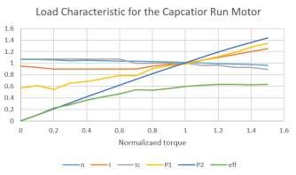
Figure 2:load characteristic of capacitor run motor

Q5: Compare the motor behavior from the plots with the expected behavior of a capacitor run motor
Ans: The plots are close to the expected behavior of the capacitor-run motor; the input power and the output power increase with the increase of the torque, also the current increases, while the speed decreases with the increase of the torque. The efficiency increases to some point then it becomes almost constant.

B. Capacitor start motor
The circuit was connected as shown in Figure2, and the isolating variable transformer was set to 30 volts V. then, the ON button of the machine test system was pressed. The input voltage was slowly increased from 30 to 80 V, and the following was observed:
-The speed at which the centrifugal switch opens:
1120rpm
-The speed at which the switching occurs: 900rpm

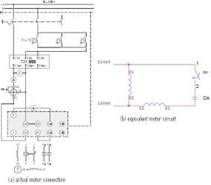
Figure 3: the circuit to study the capacitor start motor
After pressing the OFF button of the power circuit breaker module, the isolating variable transformer was set to 230 V, then, the ON button of the power circuit breaker module and the RED button of the machine test system were pressed. Next, The following table was filled:
Table 3: Measurement for Load Characteristic recording for the capacitor start motor
 | T/TN,act | 0.0 | 0.1 | 0.2 | 0.3 | 0.4 | 0.5 | 0.6 | 0.7
 | T/[Nm] | 0.0XT_{N} | 0.71 | 0.342 | 0.513 | 0.684 | 0.85 | 1.02 | 1.19
Measure | n/[rpm] | 1482 | 1470 | 1457 | 1445 | 1429 | 1413 | 1389 | 1370
 | I/[A] | 2.1 | 2 | 2 | 2 | 2 | 2.1 | 2.3 | 2.4
 | Cos (θ) | 0.4 | 0.4 | 0.47 | 0.5 | 0.55 | 0.6 | 0.65 | 0.71
 | I_{C}/[A] | 0.1 | 0.1 | 0.1 | 0.1 | 0.1 | 0.1 | 0.1 | 0.1
calculate | n/n_{N} | 1.05857 | 1.05 | 1.04071 | 1.03214 | 1.02071 | 1.00928 | 0.99214 | 0.97857
 | I/IN,act | 1.12903 | 1.07526 | 1.07526 | 1.07526 | 1.07526 | 1.12903 | 1.23655 | 1.29032
 | IC/ICN | 0.07142 | 0.07142 | 0.07142 | 0.07142 | 0.07142 | 0.07142 | 0.07142 | 0.07142
 | P₁/[W] | 33193.20 | 184.0051 | 216.2061 | 230.0063 | 253.0069 | 289.8083 | 343.8596 | 391.9312
 | P1/P1N | 0.45617 | 0.43445 | 0.51048 | 0.54306 | 0.59737 | 0.68426 | 0.81188 | 0.92538

Plots
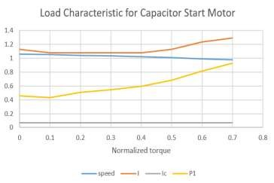
Figure 4:load characteristic for start motor
Q6: Compare the motor behavior with the expected behavior of a capacitor start motor
Ans: The plots behaves the expected behavior of the capacitor-start motor; the input power increases with the increase of the torque. The current first remains almost constant (because of the existence of the capacitor) then increases (after the switch opens).The speed of rotation decreases with the increase of the torque.

C. Computer based Recording of Run-up Characteristics of capacitor motor
In this part, the computer was used to plot curves that represent the behavior of the capacitor start motor, capacitor run motor and capacitor start and capacitor run motor at two values of voltage (230V and 125 V).
Capacitor start and capacitor run motor was connected as the following figure.

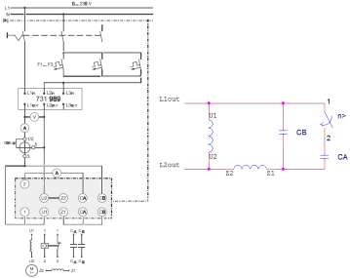
Figure 5:Circuit connection for capacitor start capacitor run motor
The starting torque of the Capacitor-Start motor is very high, here it exceeds 150% of its rated value. The Capacitor-Run motor has a smooth torque, but it has less starting torque than the previous motor, because the capacitor is sized to balance the currents in the main and the auxiliary windings at normal conditions only. While in the Capacitor-Start, Capacitor-Run motor, a large capacitance (C_{start} + C_{run}) is present in the circuit during starting, which balances the currents in the main and the auxiliary windings during starting, yielding a very high starting torque. In both, Capacitor-Start, Capacitor-Run motor and Capacitor-Start motor, a centrifugal switch disconnects the starting capacitor when the motor speeds up, while in the Capacitor-Run motor, no centrifugal switch is required, Moreover, it has a higher pullout torque.

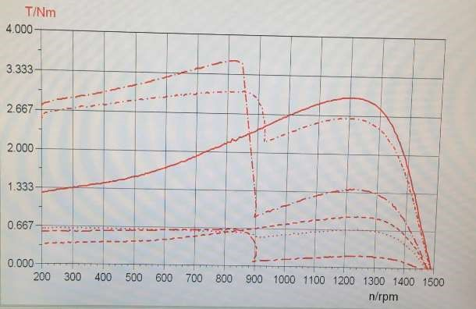
Figure 6: Torque-speed characteristic for IM

D. Separate winding induction motor (bifilar wound motor)
The circuit was connected as shown in Figure 7

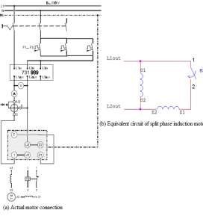
Figure 7: Circuit for studying separate winding induction motor
The nominal data for the machine under test were entered in Table 4
Table 4: Nominal Data for the machine under test
Nominal Voltage V_{N} | 230
Nominal Current I_{N} | 3 A
Nominal Power P_{N} | 0.2 kW
Nominal speed n_{N} | 1420 rpm
Based on the data obtained previously, the machine’s nominal torque was calculated as follows: T_{N}= P_{N}/w_{N} = 200/148.6 = 1.34 N.m
After setting the operating mode to torque regulation, the ON button of the power circuit breaker module and the RED button of the machine test system were pressed, then, the nominal torque was set as a load for the motor and the output power was calculated.
P₂ = T_{N} * W
-The torque=1.34 N.m -The speed=1418 rpm
>> P₂ = 198.879 Watt
The following measurements were taken:
-The input voltage=230 V.
-The input current= 3.25 -The power factor =0.6 -The speed= 1418 rpm.
-The torque= 1.34 N.m

Q7: Using the values obtained in step 8 calculate the actual efficiency?

P_{OUT}=Txw=1.34 x 1418 x (2π/60)= 198.879 watt. P_{IN}= V_{l} I_{l} cosθ= 230 x 3.25 x 0.6 = 448.49watt.
η= P_{OUT}/P_{IN} x 100% = 44.34%
Q8: Using the data obtained in Table 4, calculate the theoretical efficiency? Compare both values of efficiencies
P_{OUT}=200 watt.
P_{IN}= V_{lN} I_{lN} cos( θ_{N} )= 230 x 3 x 0.6= 414.012watt
The nominal power factor was considered to be 0.6, as measured practically.
η= P_{OUT}/P_{IN} x 100%= 48.307%
As noticed, this value is close to the value calculated in the previous question.
In order to study the load characteristics of the motor, the load torque was set to be (0.0XT_{N}), the speed (n), the input current (I) and the power factor (PF) were measured, then Table 5 was filled for various values of the torque.
Table5::Measurement for Load Characteristic recording for the split phase Induction motor
 | T/TN,act | 0.0 | 0.1 | 0.2 | 0.3 | 0.4 | 0.5 | 0.6 | 0.7
 | T/[Nm] | 0.0XT_{N} | 0.134 | 0.268 | 0.402 | 0.54 | 0.67 | 0.8 | 0.99
Measure | n/[rpm] | 1487 | 1480 | 1475 | 1470 | 1464 | 1458 | 1452 | 1441
 | I/[A] | 3.3 | 3.3 | 3.3 | 3.2 | 3.1 | 3.1 | 3.15 | 3.15
 | Cos (θ) | 0.3 | 0.35 | 0.4 | 0.41 | 0.42 | 0.45 | 0.49 | 0.51
 | n/n_{N} | 1.04718 | 1.04225 | 1.03873 | 1.03521 | 1.03098 | 1.02676 | 1.02253 | 1.01478
calculate | I/I N,act | 1.01538 | 1.01538 | 1.01538 | 0.98461 | 0.95384 | 0.95384 | 0.96923 | 0.96923
 | P₁/[W] | 227.7061 | 265.6576 | 303.6085 | 301.7684 | 299.4682 | 320.8591 | 355.0150 | 369.5057
 | P1/P1N | 0.55 | 0.64166 | 0.73333 | 0.72888 | 0.72333 | 0.77500 | 0.85750 | 0.89250
 | P₂/[W] | 0.0 | 20.7574 | 41.3747 | 61.8517 | 82.7452 | 102.244 | 121.580 | 149.316
 | P2/P2N | 0.0 | 0.10378 | 0.20687 | 0.30925 | 0.41372 | 0.51122 | 0.60790 | 0.74658
 | Ŋ | 0.0 | 0.078130 | 0.136273 | 0.204947 | 0.276305 | 0.318653 | 0.342451 | 0.404092
 | T/TN,act | 0.8 | 0.9 | 1.0 | 1.1 | 1.2 | 1.3 | 1.4
 | T/[Nm] | 1.07 | 1.21 | 1.34 | 1.47 | 1.61 | 1.74 | 1.88
 | n/[rpm] | 1436 | 1427 | 1418 | 1406 | 1393 | 1379 | 1360
Measure | I/[A] | 3.15 | 3.2 | 3.25 | 3.3 | 3.5 | 3.5 | 3.7
 | Cos (θ) | 0.54 | 0.57 | 0.6 | 0.62 | 0.65 | 0.67 | 0.7
 | n/n_{N} | 1.01126 | 1.00492 | 0.99859 | 0.99014 | 0.98098 | 0.97112 | 0.95774
 | I/I N,act | 0.96923 | 0.98461 | 1.0 | 1.01538 | 1.07692 | 1.07692 | 1.13846
calculate | P₁/[W] | 391.2413 | 419.5317 | 448.5127 | 470.5935 | 523.2650 | 539.3654 | 595.7159
 | P1/P1N | 0.94500 | 1.01333 | 1.08333 | 1.13666 | 1.26388 | 1.30277 | 1.43888
 | P₂/[W] | 160.822 | 180.724 | 198.879 | 216.327 | 234.739 | 251.143 | 267.611
 | P2/P2N | 0.80411 | 0.90362 | 0.99439 | 1.08163 | 1.17369 | 1.25571 | 1.33805
 | Ŋ | 0.411055 | 0.430765 | 0.443409 | 0.459672 | 0.448588 | 0.465613 | 0.449211

The RED button of the machine test system and the OFF button of the power circuit breaker module were pressed.

Plots:
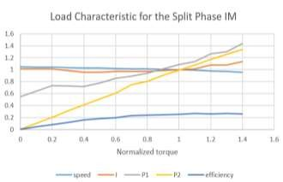
Figure 8:load characteristic for split phase IM

Starting torque is low, typically 100 to 175% of rated load, while the maximum running torque ranges from 250 to 350% of normal. Also, the motor develops high starting current, approximately 700 to 1,000% of rated. Consequently, prolonged starting times cause the start winding to overheat and fail.
The computer was used to plot curves that represent the behavior of the separate winding induction motor at 230V and 130V.

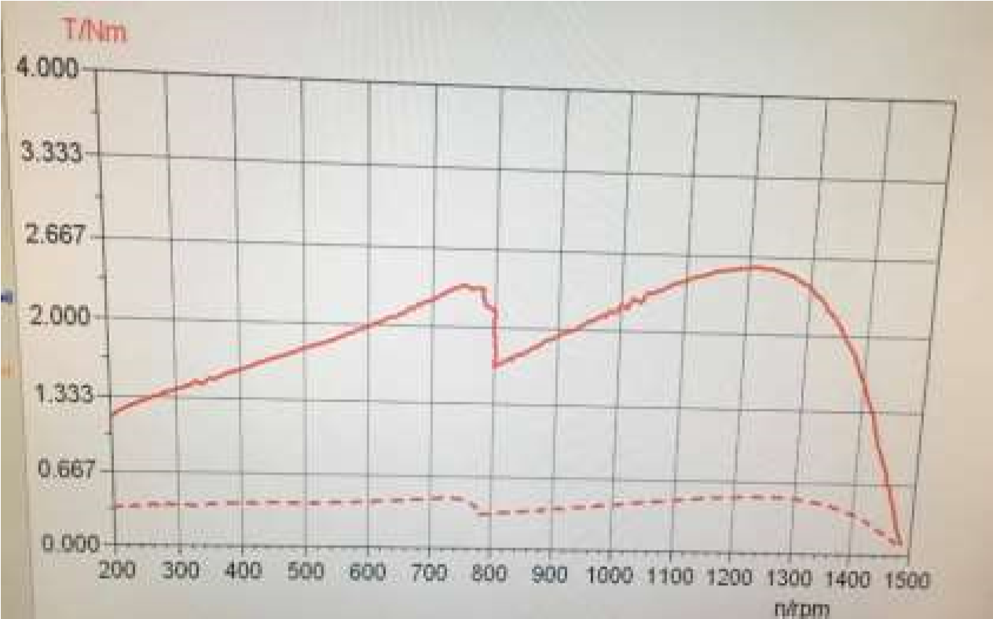
Figure 9:Computerized curve that represent the torque speed characteristic for split-phase IM
The split-phase motor has a moderate starting torque, because the angle between the auxiliary current and the main current is small, with a fairly low starting current, as noticed, as the motor speeds up, the centrifugal switch disconnects the auxiliary windings.

Conclusion:
By the end of this experiment, all the objectives were achieved; starting with how to connect, start, and reverse the direction of each investigated motor. And finishing with getting to know each motor load characteristic.
A single phase Induction motor is not self-starting, hence, four methods of starting this motor were carried out; first, the capacitor-run motor, which is also called a permanent splitcapacitor motor. This method is more efficient, has a higher power factor, and has a smoother torque than an ordinary single phase IM at normal loads, on the other hand, it has less starting torque and a starting current that is much greater than the rated current, but higher pullout torque. Moreover, no centrifugal switch is required.
The second method that was executed is the capacitor-start motor, this motor develops a much higher starting torque of about 3 to 4.5 times of the full load torque. But in order to obtain a high starting torque, two conditions are essential; the starting capacitor value must be large and the value of the starting winding resistance must be low. In this method a centrifugal switch is needed.
The third method is the capacitor-start, capacitor-run motor, it has two capacitors. This motor has the largest possible starting torque and the best running conditions amongst other single phase motors. Its permanent capacitor is large enough to balance the currents at normal conditions.
The last method is the split-phase (separate) winding IM, in all the motors mentioned previously, the phase shift between the main current and the auxiliary current is typically 90 degrees, but in this type of motor it is in the range: 30-45 degrees. It has a moderate starting torque, with a fairly starting current.
Systematic errors existence may be referred to several reasons; such as estimating the reading of the Ammeter and the power factor meter.

References:

[1] lab manual
[2] Electrical Machinery Fundamental "fifth edition"

